**Sprint 1**

|  |  |
| --- | --- |
| **Date** | 05 November 2022 |
| **Team ID** | PNT2022TMID26051 |
| **Project Name** | Smart Crop Protection System for Agriculture |
| **Maximum Marks** | 20 Marks |

Create the IBM Cloud Services Which are being used in the project

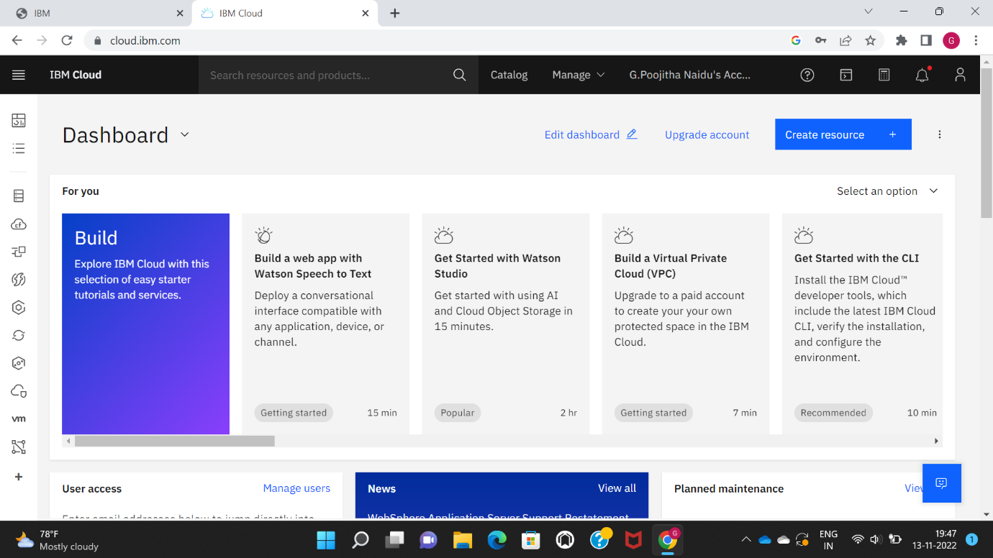

Configure the IBM Cloud Services Which are being used in completing this project

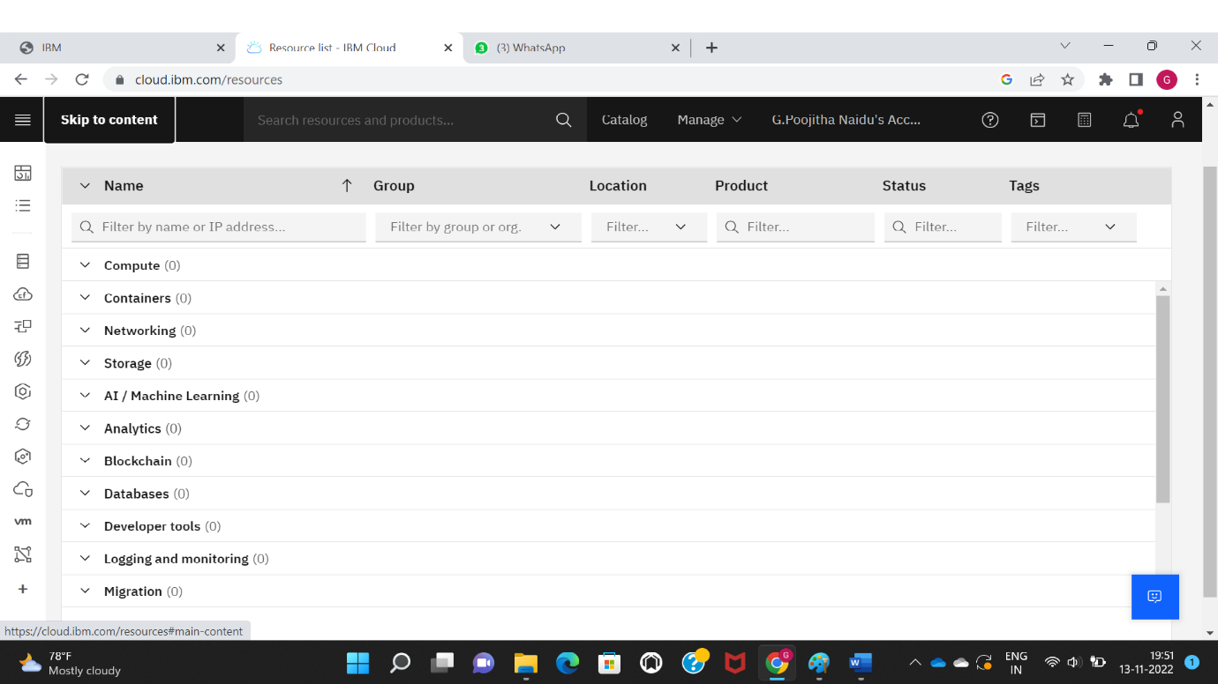

IBM Watson IoT platform acts as the mediator to connect the web application to IoT devices, so create the IBM Watson IoT platform

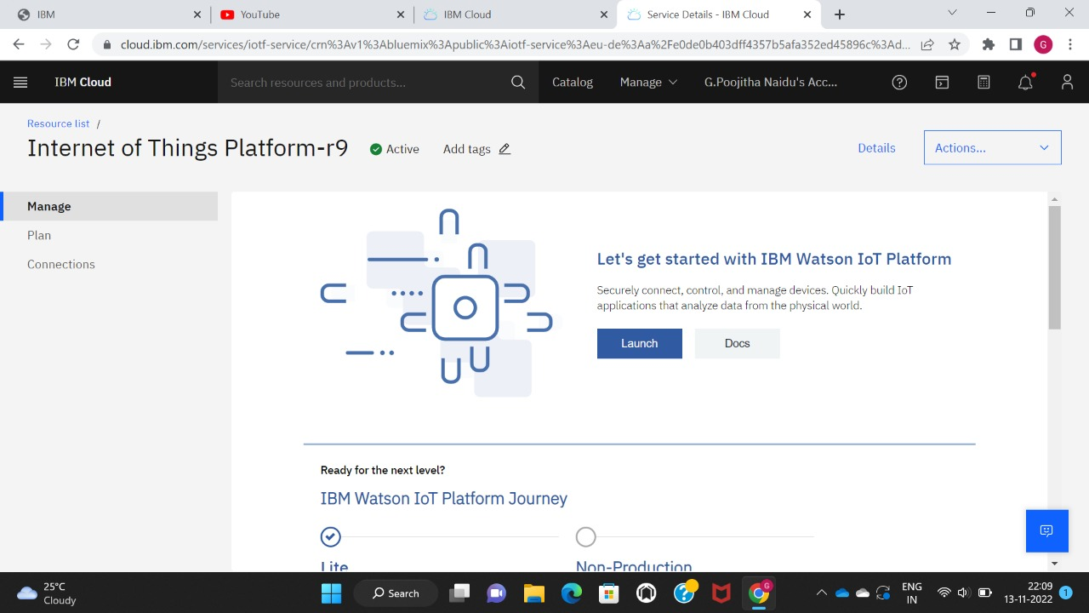

In order to connect the IoT device to the IBM Cloud create a device in the IBM Watson IoT platform and get the device credentials

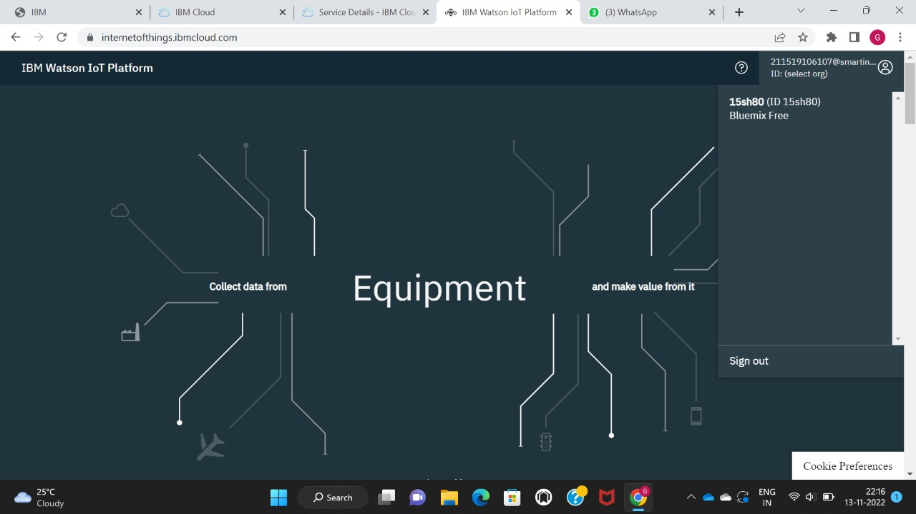

Device Credentials:

